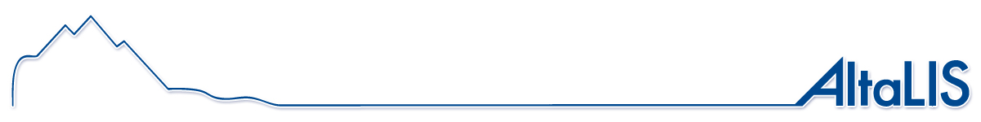
ASRD Management Area

Digital Mapping for Alberta
www.AltaLIS.com

AltaLIS is responsible for the distribution of several digital mapping datasets, including Base Features that are maintained by the Government of Alberta, to the private sector. Base Features is made up of several topographic themes that cover Alberta, and is a seamless GIS spatial database product to which other natural resource and land management information can be related.

Alberta Sustainable Resource (ASRD) Management Area is one of several GeoAdministrative layers maintained within the Base Feature dataset. GeoAdministrative boundaries are land areas that have explicitly defined boundaries, established by legislation or by an agency to manage or administer land use.

The positional accuracy is dependant upon the various sources used for creation. See the 1:20000 Base Feature products for more detail. The information contained within this data set is a mapping representation only and is not an official definition of these boundaries. AltaLIS cannot provide technical support for this free layer, but updates will be posted as they are received.

The following information has been compiled to support this boundary file:

Abstract & Purpose | The ASRD Management Area dataset is comprised of all the polygons  That represent the management areas established for the Department  of Alberta Sustainable Resource Development (ASRD) to provide services  and management of the province's sustainable resources.  It provides users with GIS ready polygonal representation of all the  management areas and is suitable for indexing or analysis purposes.
Time Period of Content: 2008 09 01

Metadata:

Coordinate system type: Geographic Geodetic Datum: North American 1983
Projection: Cylindrical Equirectangular Reference Ellipsoid: GRS80

Longitude Of Origin: 0:00:00.000 (d:m:s) Horizontal storage unit: 0.000000278 deg
Latitude Of Origin: 0:00:00.000 (d:m:s) Vertical storage unit: 1 m
Standard parallel: 0:00:00.000 (d:m:s) Storage center: Longitude: 0.000 deg
Latitude: 0.000 deg
False X: 0.00 m Height: 0.00 m
False Y: 0.00 m GeoNad83

